Interface ID: 30
Created by: Mark Lund
Created Date: 8-26-2004

Description of Design Concept:
The WSP Driver Inquiry process is a Windows Service that accepts driver inquiry messages from WSP. WSP sends the inquiry message to DOL via the vsMSSGatewayDB service which places the message in a “Driver” MSMQ queue. The dsdDriverInquiryService reads the message from the “Driver” queue, calls the MAXSO web service to obtain the data and returns the data to WSP via the DBQTx queue and the vsMSSGatewayDB service.

Decomposition/Flow Diagram: 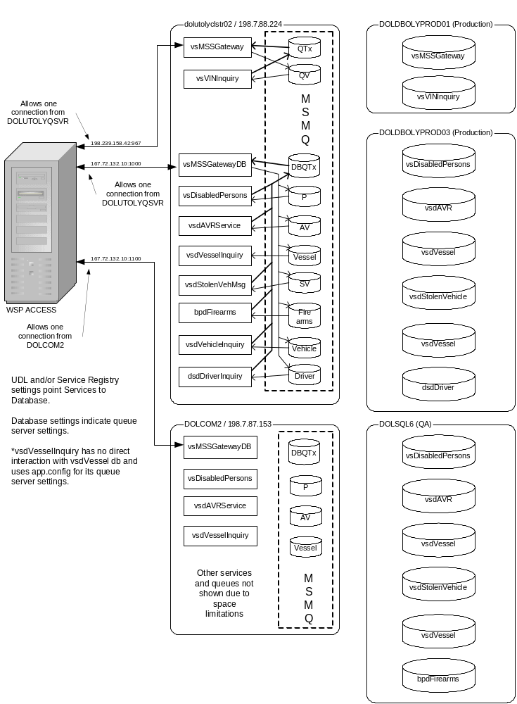
WSP – DOL Queue Environment

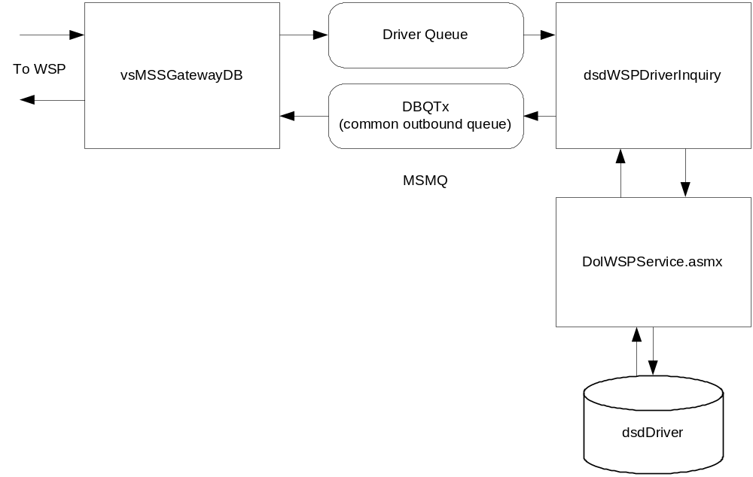
Message Transaction Flow

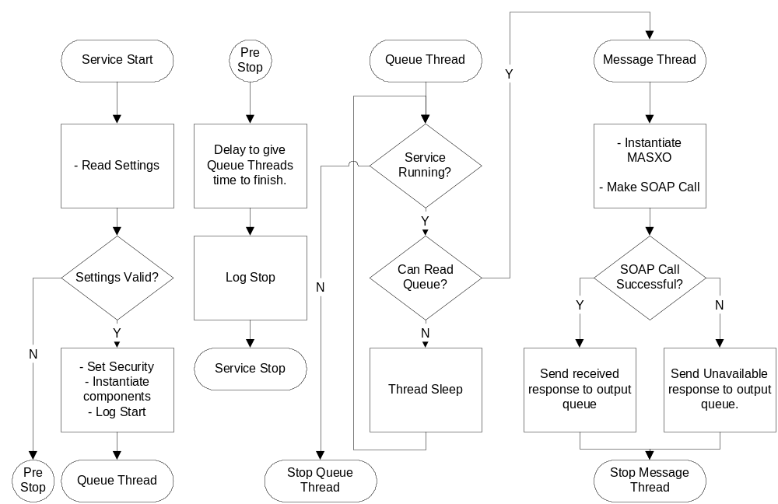
Code Flow

Functional Specifications:

Component Name: dsdWSPDriverInquiry.exe
Functionality:
- The main process and runs as a Windows Service. The Code Flow diagram shows the general flow of the program.
- The process supports multiple threads to improve performance. The number of threads are controlled via dsdWSPDriverInquiry.exe.config file settings.
- Timing, the web service security context, and queue information is also stored in the dsdWSPDriverInquiry.exe.config file. If changes are made to the dsdWSPDriverInquiry.exe.config, the service must be stopped/re-started since the config file values are only read at start-up time.
- To make the web service call as a specific user account, set the Username, Password, and Domain values of the desired Windows user account. Note – the UseSystemCredentials key is ignored when defining specific user credentials.
- To make the web service call as the user account under which the service runs, set Username, Password, and Domain values to empty strings, set the UseSystemCredentials key to “True” and configure the service to run under the desired account.
- To make the web service call as anonymous, set the Username, Password, and Domain values to empty strings and set UseSystemCredentials to “False”. When no credentials are defined, the service will make the call anonymously.
- The Code Flow diagram above shows the primary flow.

Component Name: WA.DOL.VSD.WSPQueue
Functionality:
- This component encapsulates the MSMQ queue functionality and the WSP Message formatting. This re-usable component was developed as part of UAR Vessels and was used for UAR Vehicles and the Stolen Vehicle project.

Code:

Imports System.ServiceProcess
Imports System.Threading
Imports System.Web
Imports WA.DOL.LogEvent.LogEvent

Public Class svrMain
Inherits System.ServiceProcess.ServiceBase

'module level parameters
Private MaxThreads As Integer = 20 'max concurrent threads
Private ThreadCount As Integer = 0 'number of threads spawned
Private QueueTxName As String = "PRIVATE$\DBQTx" 'name of the common output queue
Private QueueRxName As String = "PRIVATE$\Driver" 'name of the input queue
Private QueueServer As String = "DOLUTOLYVSDEV1" 'queue server path name
Private QueueSleepWhenEmpty As Integer = 500 'number of milliseconds to wait when the queue is empty before checking again
Private DebugMode As Byte = 0
Private QueueTxObject As WA.DOL.VSD.WSPQueue.QueueObject 'common output queue object
Private LogEventObject As New WA.DOL.LogEvent.LogEvent()
Private Const REGION_PREFIX As String = "DQR2." 'Unisys requires regional codes that are not passed over the TCP/IP line

Private ProxyName As String = ""
Private UserName As String = ""
Private Password As String = ""
Private Domain As String = ""
Private UseSystemCredentials As Boolean = False
Private PreAuthenticate As Boolean = False
Private Credentials As Net.NetworkCredential
Private Proxy As New System.Net.WebProxy()
Private Enum ServiceStates
Shutdown = 0
Paused = 1
Running = 2
End Enum
Private ServiceState As ServiceStates = ServiceStates.Paused

Protected Overrides Sub OnStart(ByVal args() As String)
' Add code here to start your service. This method should set things
' in motion so your service can do its work.

Try
'read the app settings
ReadAppSettings()
'validate settings
If Not ValidSettings() Then
'we read all of the values but do not
'have valid parameters and thus are unable
'to continue. Throw error to drop into exception catch
Throw New Exception("Invalid settings at start up. Unable to proceed.")
End If
'set the credentials if present
If UserName <> "" AndAlso Password <> "" AndAlso Domain <> "" Then
'use the credentials supplied in the .cong file
Credentials = New Net.NetworkCredential(UserName, Password, Domain)
ElseIf UseSystemCredentials = True Then
'use the credentials of the account we are running under
Credentials = System.Net.CredentialCache.DefaultCredentials()
End If
'set the proxy if a name is specified
If ProxyName <> "" Then
Proxy = New System.Net.WebProxy(ProxyName, True)
'set the credentials of the proxy if we have credentials
If Not Credentials Is Nothing Then
Proxy.Credentials = Credentials
End If
End If
'instantiate our common output queue object
QueueTxObject = New WA.DOL.VSD.WSPQueue.QueueObject(QueueServer, QueueTxName)
Catch ex As Exception
'LogEvent, Send E-mail, and quit
Dim strMessage As String = "Service is unable to proceed. Shutting down. " & ex.Message
'log the error
LogEvent("Service_OnStart", strMessage, MessageType.Error, LogType.Standard)
OnStop()
Exit Sub
End Try
'set our status to run mode
ServiceState = ServiceStates.Running
'make note that we started
LogEvent("OnStart", "Service Started", MessageType.Start, LogType.Standard)
'start an endless loop for processing the queue
ThreadPool.QueueUserWorkItem(AddressOf ProcessQueue)
End Sub

Protected Overrides Sub OnStop()
' Add code here to perform any tear-down necessary to stop your service.
'warn threads we are shutting down
ServiceState = ServiceStates.Shutdown
'give threads 20 seconds to wrap things up (this should be more than enough time)
Dim EndWait As Date = Now.AddSeconds(20)
While Now <= EndWait
If ThreadCount = 0 Then
Exit While
End If
End While

'log event that we are stopping
LogEvent("OnStop", "Service Stopped", MessageType.Finish, LogType.Standard)
End Sub

Private Sub LogEvent(ByVal Source As String, _
ByVal Message As String, ByVal MessageType As MessageType, _
ByVal LogType As LogType)
'Purpose: Write an event to the event log database of the specified type.
'Input: Source = source procedure reporting the event.
' Message = event message.
' MessageType = LogEvent object indicator specifying whether the
' message is error, informational, start, finish, or debug
' LogType = LogEvent object indicator
'Returns: None
'Note: When an LogType is error, an e-mail is automatically sent

'log message
LogEventObject.LogEvent(Me.ServiceName, Source, Message, MessageType, LogType)

'if message type is an error, also log an email event
If MessageType = MessageType.Error Then
LogEventObject.LogEvent(Me.ServiceName, Source, Message, MessageType, LogType.Email)
End If
End Sub

Private Sub ProcessMessage(ByVal State As Object)
'Purpose: Worker thread process to run the Fujitsu program
'Input: State - new thread callback interface containing
' a WSPMessage object.
'Returns: None.
Dim WspRequest As New WA.DOL.VSD.WSPQueue.WSPMessage()
Dim WspResponse As New WA.DOL.VSD.WSPQueue.WSPMessage()
Dim datStart As Date = Now
'get the object into a typed class
WspRequest = CType(State, WA.DOL.VSD.WSPQueue.WSPMessage)
'log the request
If DebugMode > 0 Then
LogEvent("ProcessMessage", "Request: " & WspRequest.Body, MessageType.Debug, LogType.Standard)
End If

'pass message to Fujitsu EXE
Const strUNAVAILABLE As String = "TEMPORARILY UNAVAILABLE "
Dim strResponse As String = strUNAVAILABLE
Dim MAXSO As New gov.wa.dol.dolservicepredev.dolWSPservice()

Try
'if we have credentials, assign them to the web service request
If Not Credentials Is Nothing Then
MAXSO.Credentials = Credentials
End If

'if we have a proxy, assign it to the web service request
If Not Proxy Is Nothing Then
MAXSO.Proxy = Proxy
End If

'set PreAuthenticate
MAXSO.PreAuthenticate = PreAuthenticate

Dim IsDNQ As Boolean = False
Dim IsDQG As Boolean = False
Select Case Left(WspRequest.Body, 4)
Case "DNQ."
'NLETS name only - must respond with DNR
IsDNQ = True
'strResponse = MAXSO.CallMAXSO(REGION_PREFIX & WspRequest.Body)
Case "DQG."
'NLETS regional inquiry - must respond with DRG
IsDQG = True
'strResponse = MAXSO.CallMAXSO(REGION_PREFIX & WspRequest.Body)
Case Else
'in-state or normal NLETS
'strResponse = MAXSO.CallMAXSO(REGION_PREFIX & WspRequest.Body)
End Select
'make the call
strResponse = MAXSO.CallMAXSO(REGION_PREFIX & WspRequest.Body)

'the response string contains LF LF rather than CR LF
'remove any CRs, convert LF LF to LF, then expand LFs to CRLFs
strResponse = Replace(Replace(Replace(strResponse, vbCr, ""), vbLf & vbLf, vbLf), _
vbLf, vbCrLf)

'strip the region portion of the response per WSP 7-28-2004
strResponse = StripRegion(strResponse)

'if request was a DNQ, response must be DNR
If IsDNQ = True Then
'convert NLETS DR. response back to DNR. response if inquiry was an DNQ
strResponse = Replace(strResponse, "DR.", "DNR.", 1, 1)
ElseIf IsDQG = True Then
'convert NLETS DR. response back to DRG. response if inquiry was an DQG
strResponse = Replace(strResponse, "DR.", "DRG.", 1, 1)
End If

'trap SQL not available situation from Fujitsu
If Trim(strResponse) = "" Then
strResponse = strUNAVAILABLE
End If
Catch ex As Exception
'if this fails, log event and send e-mail
'no response message will be sent
Dim strMessage As String = "Error from MAXSO" & vbCrLf & "Request: " & WspRequest.Body _
& vbCrLf & vbCrLf & "Error: " & ex.Message
If Not ex.InnerException Is Nothing Then
strMessage &= vbCrLf & "Inner Exception: " & ex.InnerException.Message
End If
'log the error
LogEvent("ProcessMessage", strMessage, MessageType.Error, LogType.Standard)
End Try

If Trim(strResponse) = "" Then
'handle null or SQL not available situation from Fujitsu
LogEvent("ProcessMessage", "Empty response from MAXSO", MessageType.Error, LogType.Standard)
strResponse = strUNAVAILABLE
ElseIf Left(strResponse, 2) = "s!" Or Left(strResponse, 2) = "!!" Then
'handle errors from MAXSO ("s!..." or "!!...")
LogEvent("ProcessMessage", strResponse, MessageType.Error, LogType.Standard)
strResponse = strUNAVAILABLE
End If

'assign the response to the queue body
WspResponse.Body = strResponse

WspResponse.MessageDate = Now 'set the current time
WspResponse.Auxiliary = WspRequest.Auxiliary 'pass the Aux through
WspResponse.Delimiter = WspRequest.Delimiter 'pass the delimiter through
WspResponse.QueueName = QueueTxName 'specify the output queue name (not required)
WspResponse.OriginatingID = "" 'the vsMSSGatewayDB will fill this in
WspResponse.Mnemonic = WspRequest.OriginatingID 'set the dest mnemonic to the originating ID

'log the response
If DebugMode > 0 Then
Dim RunLength As System.TimeSpan = Now.Subtract(datStart)
Dim Millisecs As Integer = RunLength.TotalMilliseconds
LogEvent("ProcessMessage", "Response: (" & Millisecs.ToString & " ms) " & _
WspResponse.Body, MessageType.Debug, LogType.Standard)
End If

'lock the common send object and send the response
SyncLock QueueTxObject
QueueTxObject.SendMessage(WspResponse)
End SyncLock

'clean up
WspRequest = Nothing
WspResponse = Nothing
MAXSO = Nothing

'decrement the thread count
Interlocked.Decrement(ThreadCount)

End Sub

Private Sub ProcessQueue(ByVal State As Object)
'Purpose: Main thread to monitor the queue for inquiries.

'create a Rx object to read the queue
Dim QueueRxObject As New WA.DOL.VSD.WSPQueue.QueueObject(QueueServer, QueueRxName)

'loop here while service is running
While ServiceState = ServiceStates.Running

Dim intAvailableThreads As Integer = 0
Dim intIOThreads As Integer = 0

'check resource availability
ThreadPool.GetMaxThreads(intAvailableThreads, intIOThreads)

Try
'
'if there is at least one message in the queue and we have resources,
'start reading the queue
If QueueRxObject.CanRead = True AndAlso _
ThreadCount < intAvailableThreads AndAlso ThreadCount <= MaxThreads Then
'
'read all of the messages in the queue or until we've been shutdown
Do While QueueRxObject.CanRead AndAlso ServiceState = ServiceStates.Running

'make sure we still have resource availability
ThreadPool.GetMaxThreads(intAvailableThreads, intIOThreads)

If ThreadCount >= intAvailableThreads Or ThreadCount >= MaxThreads Then
'bail out when no threads are available or max hit;
'this will ultimately drop us into Sleep mode
Exit Do
End If

'fetch the queue message
Dim QueueMessage As New WA.DOL.VSD.WSPQueue.WSPMessage()
QueueMessage = QueueRxObject.ReadMessage
QueueMessage.Body = QueueMessage.Body & " "

'increment the thread count (each thread will decrement this when its done)
Interlocked.Increment(ThreadCount)

'process each message on a separate thread
ThreadPool.QueueUserWorkItem(AddressOf ProcessMessage, QueueMessage)
Loop
Else
'
'queue is empty or currently at the max thread count, so take nap
Thread.Sleep(QueueSleepWhenEmpty)
End If
Catch ex As Exception
'log the response
If DebugMode > 0 Then
Dim strMessage As String = ex.Message & vbCrLf & vbCrLf & "Available Threads: " _
& CStr(intAvailableThreads) & vbCrLf & "Thread Count=" & CStr(ThreadCount)
LogEvent("ProcessQueue", "Err: " & strMessage, MessageType.Debug, LogType.Standard)
End If
Thread.Sleep(QueueSleepWhenEmpty * 10)
End Try
End While 'main loop
End Sub

Private Function ReadAppSetting(ByVal Key As String) As String
'Purpose: Retrieve parameter from app.config.
'Input: Key whose value is being sought.
'Return: String value of key.

On Error Resume Next
Dim AppSettingsReader As New System.Configuration.AppSettingsReader()
Dim strReturnValue As String = ""
Key = Trim(Key)
If Key <> "" Then
'get the value
strReturnValue = AppSettingsReader.GetValue(Key, strReturnValue.GetType())
End If
AppSettingsReader = Nothing
Return strReturnValue
End Function

Private Sub ReadAppSettings()
'Purpose: Read the necessary application settings

On Error Resume Next

If ReadAppSetting("QueueTx") <> "" Then
QueueTxName = ReadAppSetting("QueueTx")
End If
If ReadAppSetting("QueueRx") <> "" Then
QueueRxName = ReadAppSetting("QueueRx")
End If
If ReadAppSetting("QueueServer") <> "" Then
QueueServer = ReadAppSetting("QueueServer")
End If
If IsNumeric(ReadAppSetting("QueueSleepWhenEmpty")) AndAlso _
CType(ReadAppSetting("QueueSleepWhenEmpty"), Integer) > 0 Then
QueueSleepWhenEmpty = CType(ReadAppSetting("QueueSleepWhenEmpty"), Integer)
End If
If IsNumeric(ReadAppSetting("DebugMode")) AndAlso _
CType(ReadAppSetting("DebugMode"), Byte) >= 0 Then
DebugMode = CType(ReadAppSetting("DebugMode"), Byte)
End If
If IsNumeric(ReadAppSetting("MaxConcurrentThreads")) AndAlso _
CType(ReadAppSetting("MaxConcurrentThreads"), Integer) > 0 Then
MaxThreads = CType(ReadAppSetting("MaxConcurrentThreads"), Integer)
End If
If ReadAppSetting("Proxy") <> "" Then
ProxyName = ReadAppSetting("Proxy")
End If
If ReadAppSetting("User") <> "" Then
UserName = ReadAppSetting("User")
End If
If ReadAppSetting("Password") <> "" Then
Password = ReadAppSetting("Password")
End If
If ReadAppSetting("Domain") <> "" Then
Domain = ReadAppSetting("Domain")
End If
If LCase(ReadAppSetting("UseSystemCredentials")) = "true" Then
UseSystemCredentials = True
End If
If LCase(ReadAppSetting("PreAuthenticate")) = "true" Then
PreAuthenticate = True
End If
End Sub

Private Sub ReturnMessage(ByVal QueueMessage As WA.DOL.VSD.WSPQueue.WSPMessage)
'Purpose: used if we need to return a message to the queue
Dim QueueRxObject As New WA.DOL.VSD.WSPQueue.QueueObject(QueueServer, QueueRxName)
QueueRxObject.SendMessage(QueueMessage)
QueueRxObject = Nothing
End Sub

Private Function StripRegion(ByVal Response As String) As String
'The Unisys returns regional information in the response that cannot be passed
'to the ACCESS switch when using the TCP/IP connection. This function
'strips these regional characters from the response.

Select Case Left(Response, 3)
Case "DQ.", "KQ.", "D .", "K .", "DW.", "DR.", "DRG", "DNR", "KR."
'nothing preppended, return what was received
Return Response
Case Else
'see if its a 2 character response
Select Case Left(Response, 2)
Case "D.", "K."
'nothing preppended, return what was received
Return Response
Case Else
'strip region field
'L1DQ R2.DR...AZNLETS2.

'find the first "." and remove everything to the left of it, including the period
Dim Position As Integer = InStr(Response, ".")
If Position > 1 Then
Return Right(Response, Len(Response) - Position)
Else
'shouldn't happen, but return response
Return Response
End If
End Select
End Select
End Function

Private Function ValidSettings() As Boolean
'Purpose: Verify we have valid settings
If QueueTxName = "" Or QueueRxName = "" Or QueueServer = "" Then
Return False
End If
Return True
End Function

Protected Overrides Sub OnShutdown()
'calls the Windows service OnStop method
OnStop()
End Sub
End Class

